DIFFERENT TYPES OF ACTIVATION FUNCTIONS IN NEURAL NETWORKS

SUBMITTED BY : G.HARSHAVARTHINI
REGISTER NUMBER : 124011101553
PROGRAMME / YEAR : B.TECH BIOTECHNOLOGY / III
COURSE CODE : U24BT02
COURSE NAME : NEURAL NETWORKS
ASSIGNMENT NO. : 1

Different Types of Activation Functions in Neural Networks
Introduction
An activation function is a mathematical function applied to the weighted sum produced by a neuron. It determines whether and how strongly the neuron should become active.
For a neuron:
$$z=\sum_{i=1}^{n}{w_{i}}x_{i}+b \\ y=f\left(z\right)$$
where:
- $x_{i}$= input values
- $w_{i}$= weights
- $b$= bias
- $z$= weighted sum
- $f\left(z\right)$= activation function
- $y$= neuron output
Activation functions introduce non-linearity, allowing neural networks to learn complex relationships. Without nonlinear activation functions, even a network with many layers behaves like a single linear model.

1. Linear Activation Function
Definition
The output is directly proportional to the input.
Formula
$f\left(x\right)=x$ (or) $f\left(x\right)=ax$

Graph
A straight line passing through the origin. For $f\left(x\right)=x$, the slope is $1$.
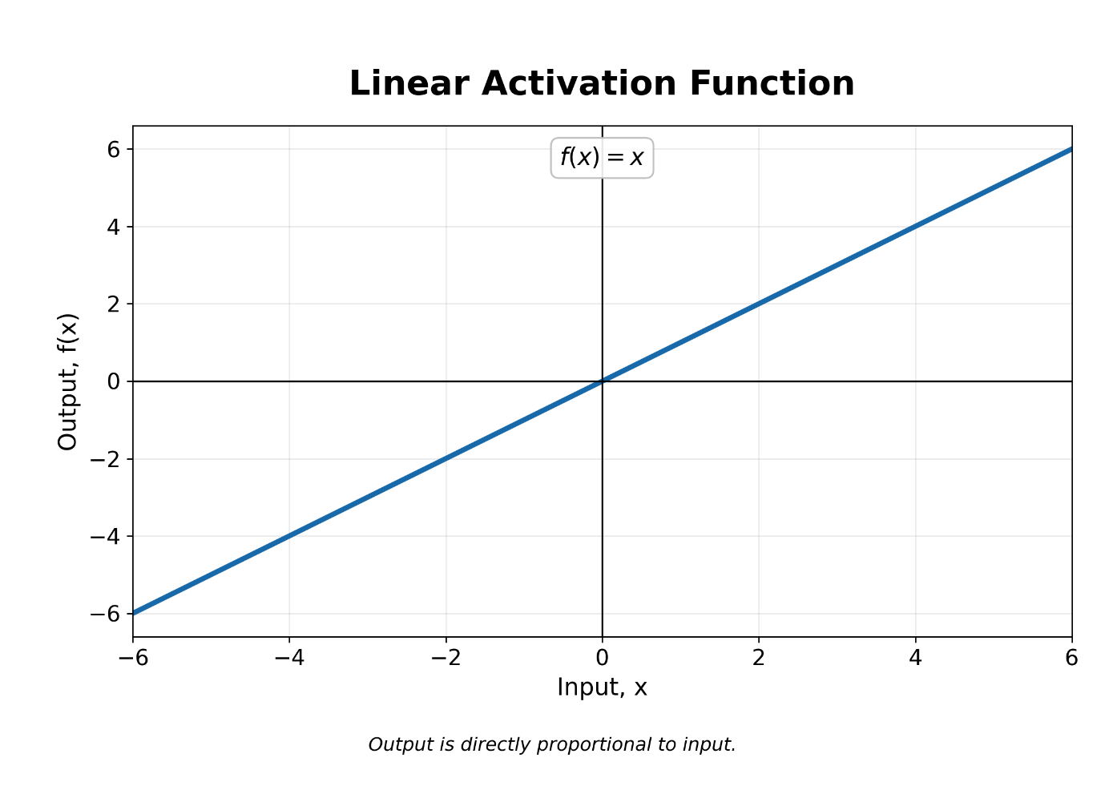
Range
$$\left(-∞ , ∞\right)$$Derivative
$$f^{'}\left(x\right)=1$$Applications
- Output layer of regression models
- Predicting continuous values such as temperature, price and concentration
Limitation
It does not introduce non-linearity. Therefore, it is generally unsuitable for hidden layers.

2. Sigmoid or Logistic Function
Definition
The sigmoid function converts any real input into a value between $0$and $1$.
Formula
$$f\left(x\right)=\frac{1}{1+e^{-x}}$$Graph
An S-shaped curve:
- Approaches $0$when $x$is highly negative.
- $f\left(0\right)=0.5$.
- Approaches $1$when $x$is highly positive.
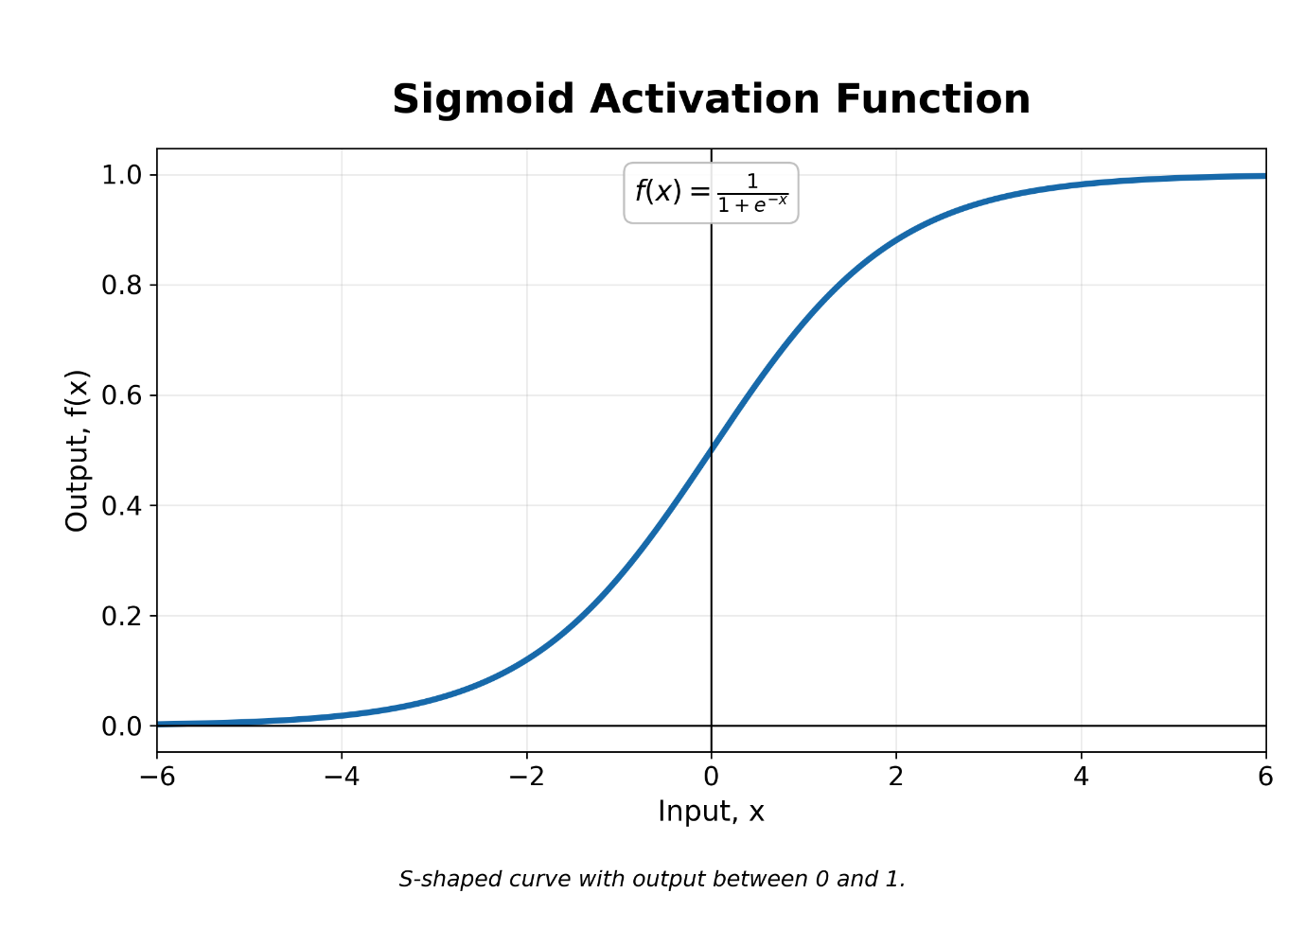

Range
$$\left(0 , 1\right)$$Derivative
$$f^{'}\left(x\right)=f\left(x\right)\left[1-f\left(x\right)\right]$$Applications
- Output layer of binary-classification networks
- Probability prediction
- Gates in LSTM and GRU networks
Advantages
- Smooth and differentiable
- Output can be interpreted as probability
Limitations
- Suffers from the vanishing-gradient problem
- Output is not zero-centred
- Computationally more expensive than ReLU

3. Hyperbolic Tangent Function—Tanh
Definition
Tanh is an S-shaped activation function similar to sigmoid, but its output ranges from $-1$to $1$.
Formula
$$f\left(x\right)=tanh⁡\left(x\right)=\frac{e^{x}-e^{-x}}{e^{x}+e^{-x}}$$Graph
- S-shaped curve centred at the origin.
- Approaches $-1$for large negative inputs.
- Passes through $\left(0 , 0\right)$.
- Approaches $1$for large positive inputs.
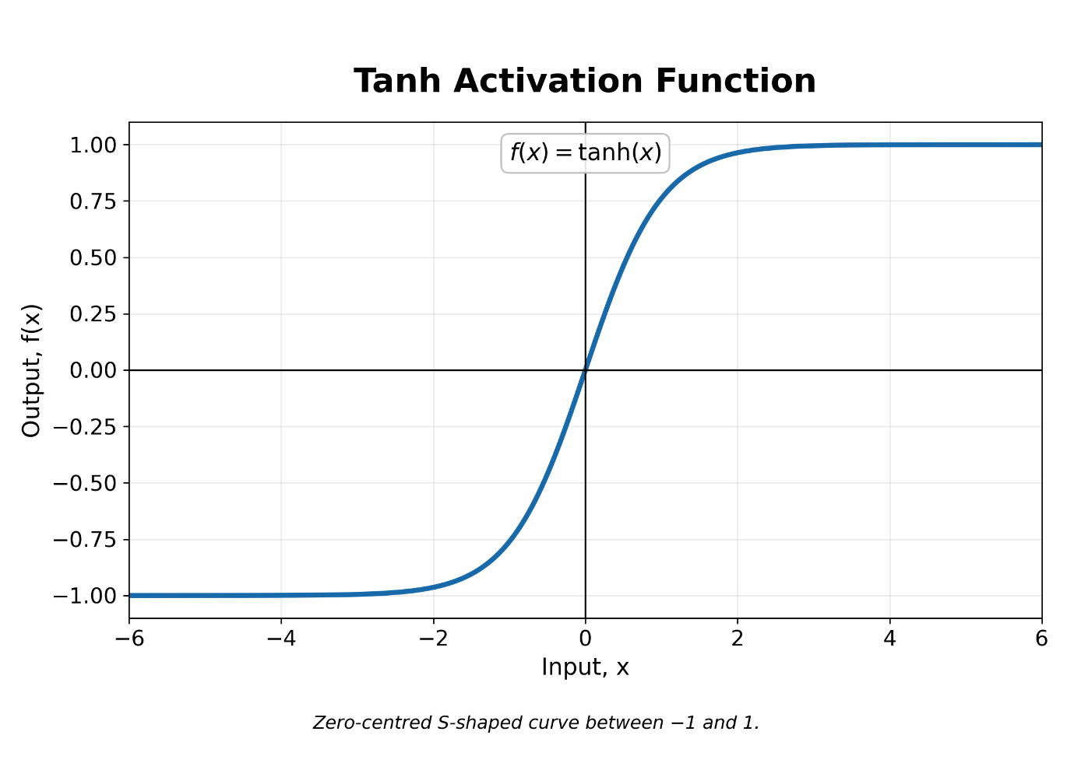
Range
$$\left(-1 , 1\right)$$Derivative
$$f^{'}\left(x\right)=1-\tanh^{2}\left(x\right)$$Applications
- Hidden layers of traditional neural networks
- Recurrent Neural Networks
- LSTM candidate-state calculations
Advantages
- Zero-centred output
- Stronger gradients near zero than sigmoid
Limitation
It can still suffer from vanishing gradients for very large positive or negative inputs.

4. Rectified Linear Unit—ReLU
Definition
ReLU outputs zero for negative inputs and passes positive inputs unchanged.
Formula
$f\left(x\right)=max⁡\left(0 , x\right)$ (or) $f\left(x\right)=\left\{\begin{matrix}0, & x<0 \\ x, & x≥0\end{matrix}\right.$
Graph
- Horizontal line at $y=0$for negative inputs.
- Straight line with slope $1$for positive inputs.
- A sharp corner occurs at the origin.
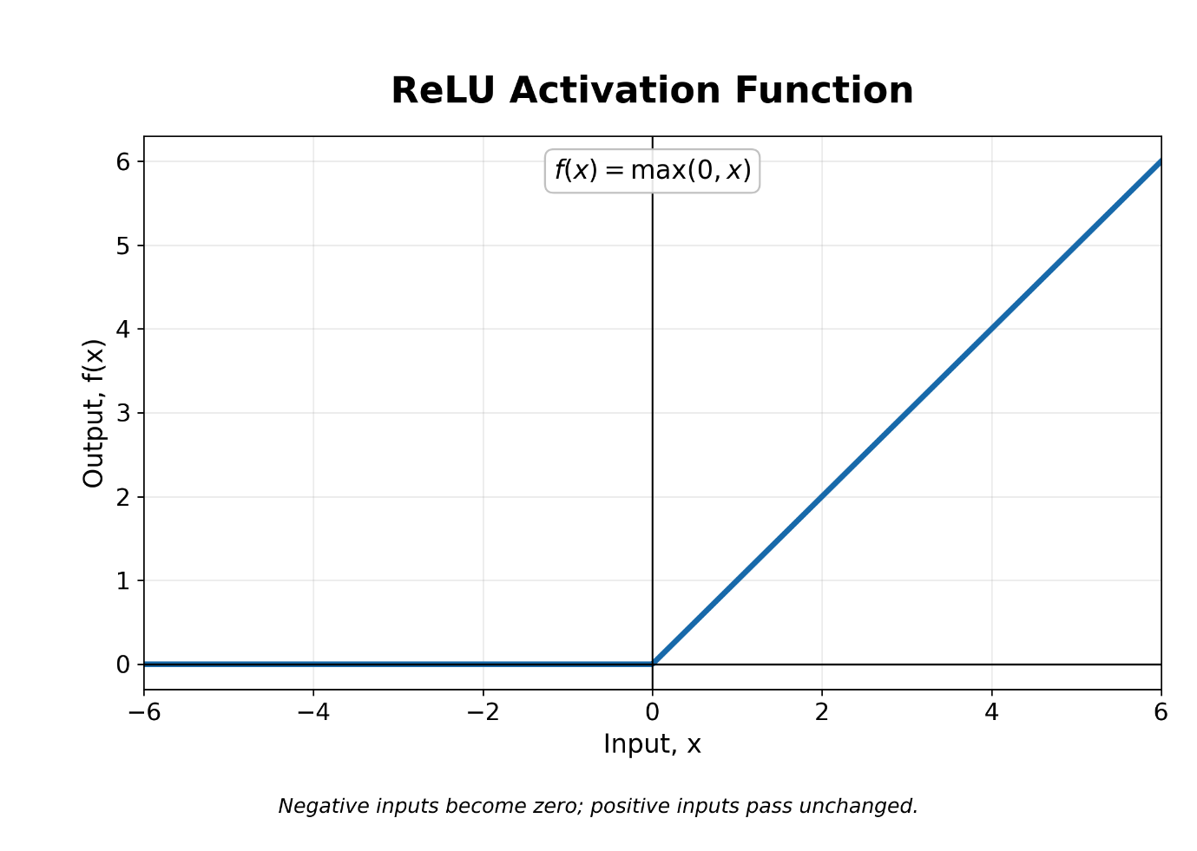
Range
$$\left[0 , ∞\right)$$Derivative
$$f^{'}\left(x\right)=\left\{\begin{matrix}0, & x<0 \\ 1, & x>0\end{matrix}\right.$$
The derivative at $x=0$is technically undefined, but it is assigned a value such as $0$during implementation.

Applications
- Hidden layers of deep neural networks
- Convolutional Neural Networks
- Image recognition and computer vision
Advantages
- Simple and computationally efficient
- Reduces the vanishing-gradient problem
- Produces sparse activation because negative outputs become zero
Limitation
Neurons can permanently output zero, producing the dying ReLU problem.

5. Leaky ReLU
Definition
Leaky ReLU allows a small negative output instead of converting all negative inputs to zero.
Formula
$$f\left(x\right)=\left\{\begin{matrix}αx, & x<0 \\ x, & x≥0\end{matrix}\right.$$Usually, $α=0.01$.
Graph
- Small positive slope on the negative side.
- Slope of $1$on the positive side.
- Both lines meet at the origin.
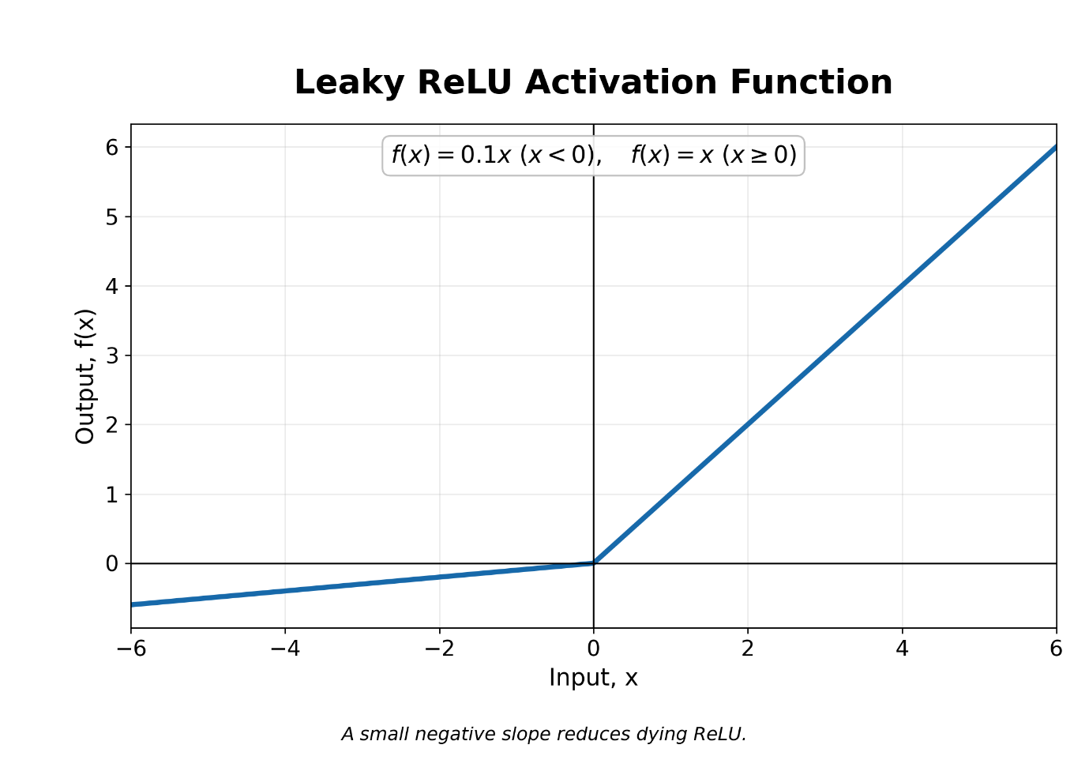
Range
$$\left(-∞ , ∞\right)$$Derivative
$$f^{'}\left(x\right)=\left\{\begin{matrix}α, & x<0 \\ 1, & x>0\end{matrix}\right.$$Applications
- Deep neural networks
- Computer-vision models
- Networks affected by dying ReLU neurons
Advantage
It maintains a small gradient for negative inputs and reduces the dying ReLU problem.
Limitation
The value of $α$must be selected manually and may not be optimal.

6. Parametric ReLU—PReLU
Definition
PReLU is similar to Leaky ReLU, but the negative slope is learned by the neural network during training.
Formula
$$f\left(x\right)=\left\{\begin{matrix}ax, & x<0 \\ x, & x≥0\end{matrix}\right.$$Here, $a$is a trainable parameter.
Graph
Similar to Leaky ReLU, but the negative-side slope changes during training.
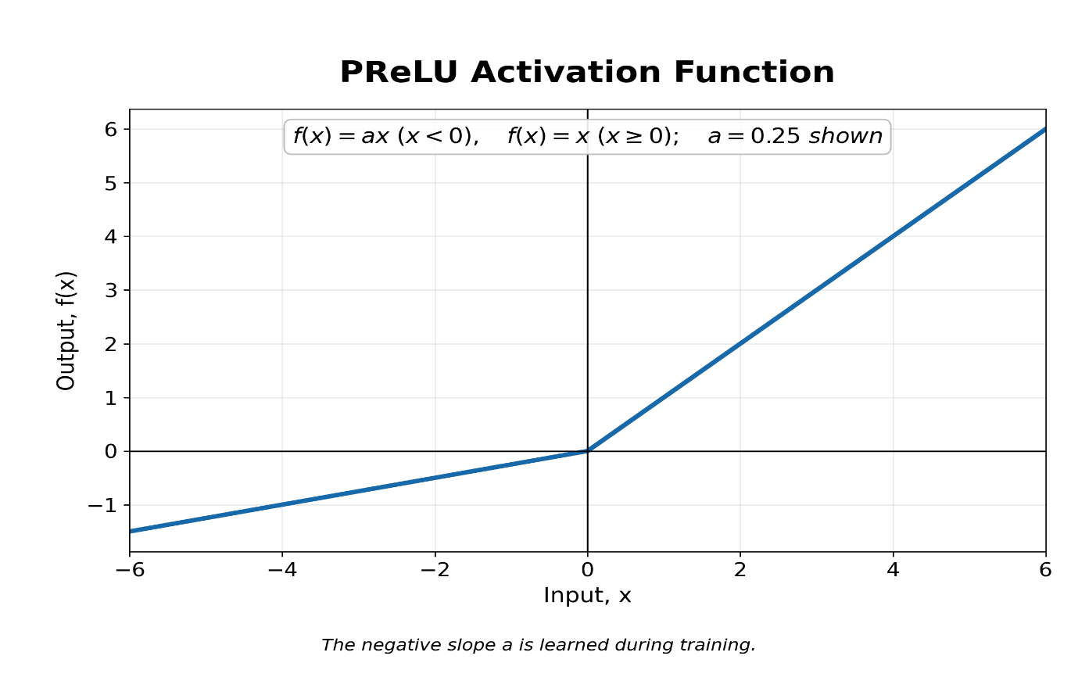
Applications
- Deep Convolutional Neural Networks
- Image classification
- Object recognition
Advantage
The network automatically learns the most suitable negative slope.
Limitation
It introduces additional parameters and may increase the risk of overfitting.

7. Exponential Linear Unit—ELU
Definition
ELU uses an exponential curve for negative inputs and a linear function for positive inputs.
Formula
$$f\left(x\right)=\left\{\begin{matrix}α\left(e^{x}-1\right), & x<0 \\ x, & x≥0\end{matrix}\right.$$Usually, $α=1$.
Graph
- Smooth exponential curve for negative inputs.
- Approaches $-α$for highly negative inputs.
- Becomes a straight line for positive inputs.
Range
$$(-α,∞)$$Applications
- Deep neural networks
- Image-classification networks
- Networks requiring smoother activation than ReLU

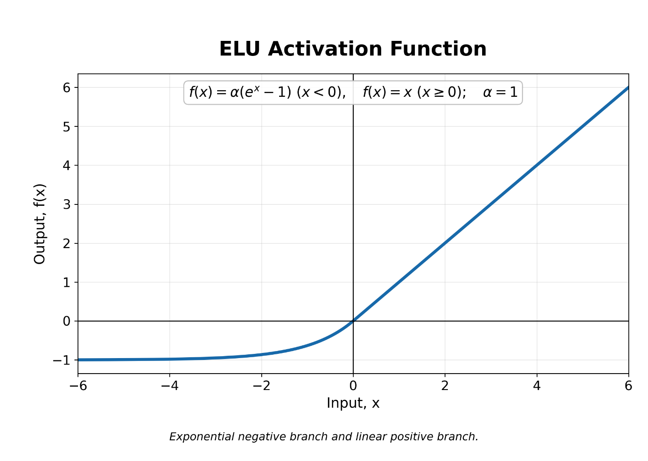
Advantages
- Reduces the dying ReLU problem
- Negative outputs help keep the mean activation near zero
- Smooth for negative inputs
Limitation
The exponential calculation makes it slower than ReLU.

8. Scaled Exponential Linear Unit—SELU
Definition
SELU is a scaled form of ELU designed to produce self-normalizing neural networks.
Formula
$$f\left(x\right)=λ\left\{\begin{matrix}α\left(e^{x}-1\right), & x<0 \\ x, & x≥0\end{matrix}\right.$$Common values are:$α≈1.6733, λ≈1.0507$
Graph
Similar to ELU, but both positive and negative outputs are scaled.
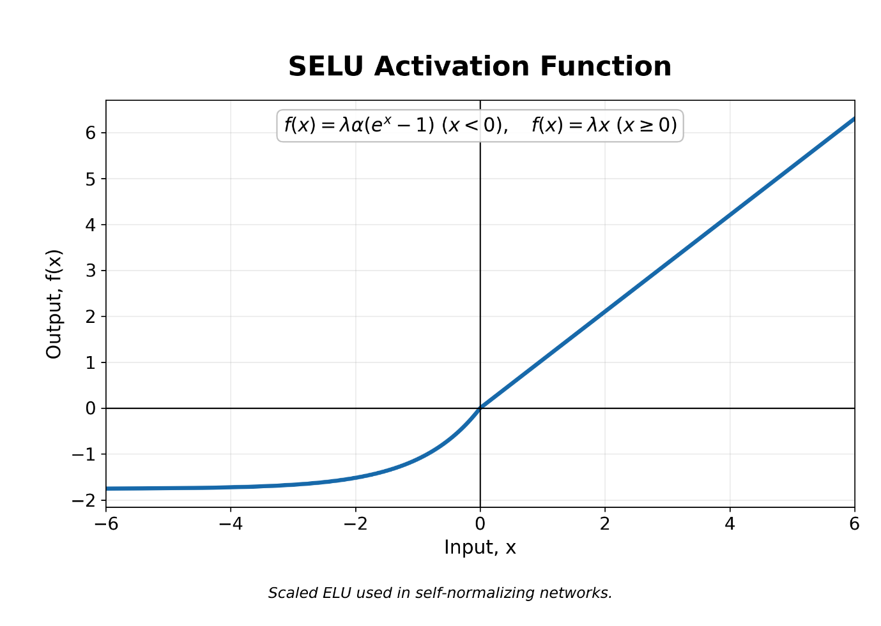
Range
$$(-λα,∞)$$Applications
- Self-normalizing neural networks
- Deep fully connected networks
Advantage
Under suitable conditions, it helps keep neuron outputs at approximately zero mean and unit variance.
Limitations
Its self-normalizing property generally requires:
- LeCun-normal weight initialization
- A specific network architecture
- AlphaDropout rather than standard dropout

9. Softplus Function
Definition
Softplus is a smooth approximation of the ReLU function.
Formula
$$f\left(x\right)=ln⁡\left(1+e^{x}\right)$$Graph
- Smooth curve rather than a sharp corner.
- Approaches zero for highly negative inputs.
- Behaves approximately like $y=x$for large positive inputs.
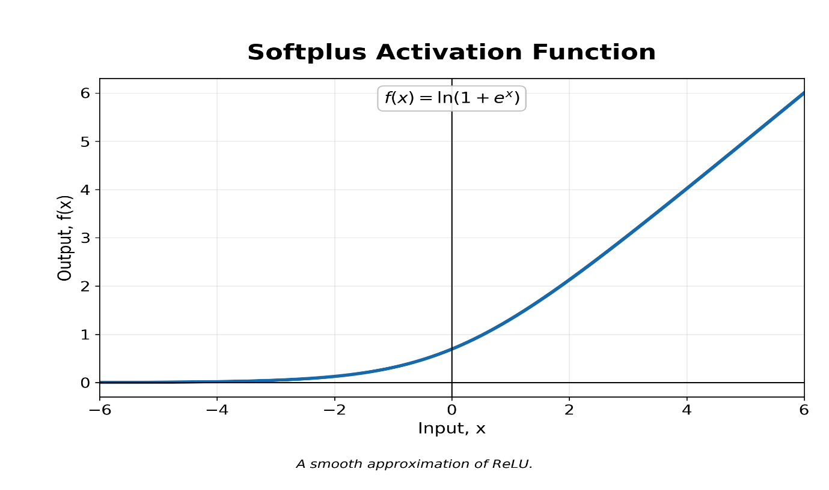
Range
$$\left(0 , ∞\right)$$Derivative
$$f^{'}\left(x\right)=\frac{1}{1+e^{-x}}$$Thus, the derivative of Softplus is the sigmoid function.
Applications
- Models requiring smooth and differentiable activation
- Predicting parameters that must remain positive
- Probabilistic and scientific neural networks
Advantage
It is differentiable at every point and does not have the sharp corner of ReLU.
Limitation
It is more computationally expensive and less sparse than ReLU.

10. Softsign Function
Definition
Softsign is a smooth activation function that maps inputs between $-1$and $1$.
Formula
$$f\left(x\right)=\frac{x}{1+∣x∣}$$Graph
An S-shaped curve similar to tanh, but it approaches its limits more gradually.
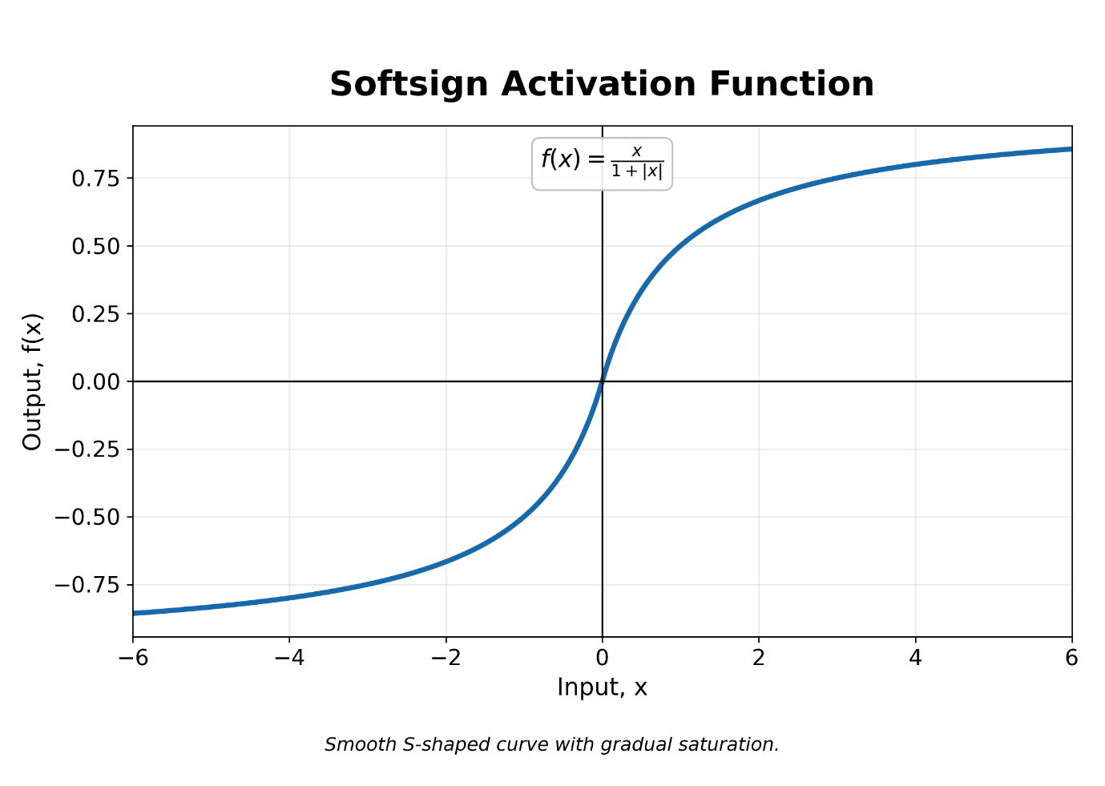
Range
$$\left(-1 , 1\right)$$Derivative
$$f^{'}\left(x\right)=\frac{1}{{\left(1+∣x∣\right)}^{2}}$$Applications
- Hidden layers of neural networks
- Situations where gradual saturation is preferred
Advantage
It saturates more slowly than sigmoid and tanh.
Limitation
It is less commonly used than ReLU and tanh.

11. Softmax Function
Definition
Softmax converts a vector of raw output values into a probability distribution. The probabilities add up to $1$.
Formula
For the $i^{th}$class:
$$f\left(z_{i}\right)=\frac{e^{z_{i}}}{\sum_{j=1}^{K}{e^{z_{j}}}}$$
where $K$is the number of classes.
Example
If the softmax output is:
$$\left[0.10 , , 0.70 0.20\right]$$the model predicts the second class with a probability of $70\%$.
Graph
Softmax does not have one standard two-dimensional graph because it operates on an entire vector. Increasing one class score increases its probability and decreases the relative probabilities of the other classes.
Range
$0<f\left(z_{i}\right)<1$ and $\sum_{i=1}^{K}{f}\left(z_{i}\right)=1$
Applications
- Output layer of multiclass-classification networks
- Image classification
- Text classification
- Recognition of multiple disease categories

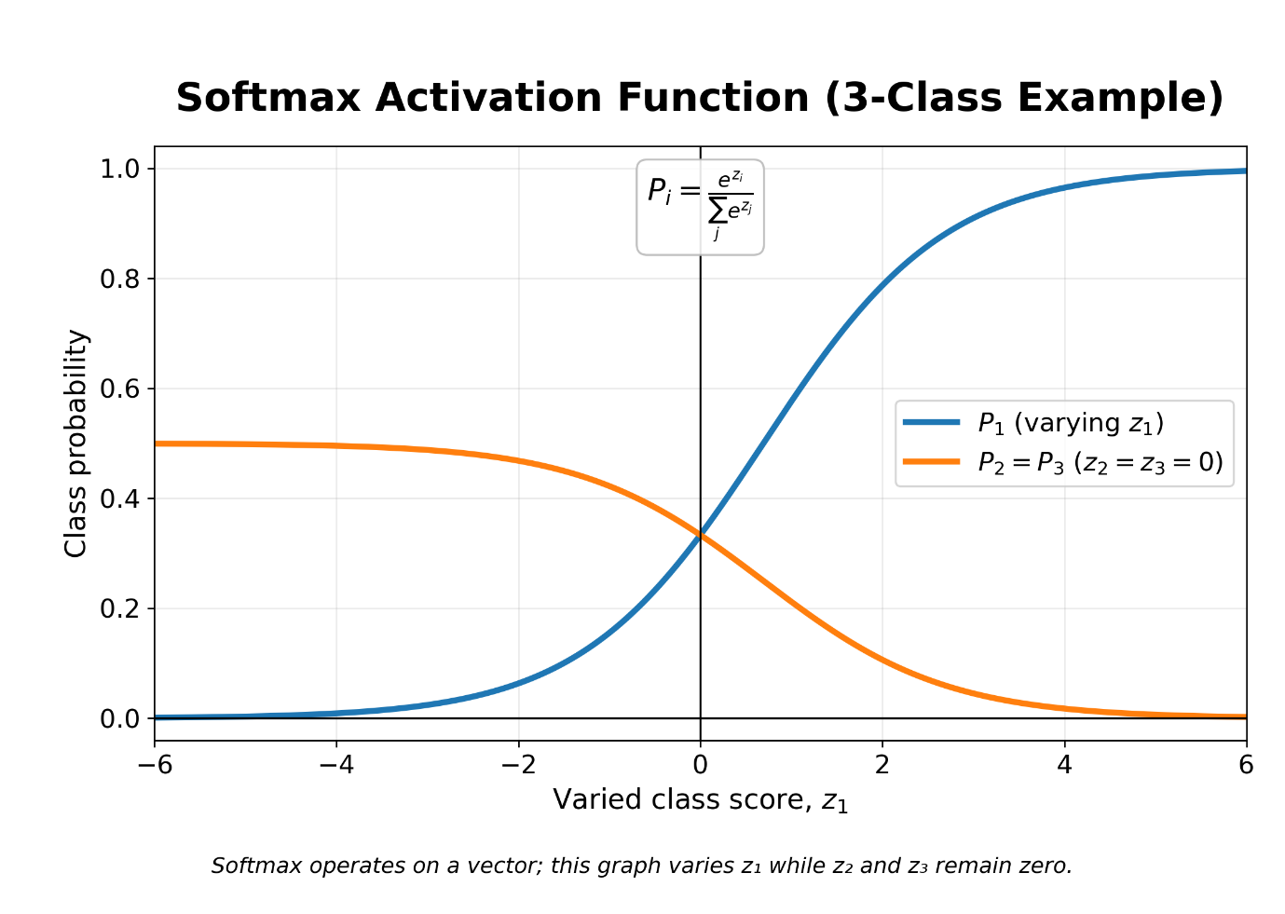

Advantage
It produces a normalized probability distribution across mutually exclusive classes.
Limitation
It is sensitive to very large input values and is unsuitable when several classes can be correct simultaneously.
Conclusion:
Activation functions determine how neurons process information and enable neural networks to learn nonlinear patterns. ReLU and its variants are widely used in hidden layers, sigmoid is suitable for binary-classification outputs, softmax is used for multiclass-classification outputs, and linear activation is commonly used for regression. Modern functions such as Swish and GELU provide smooth activation and are especially useful in advanced deep-learning architectures.

